Lecture#11 Navigation
Objectives
- Navigation
- Push
- Pop
- Push Replacement

Navigation:
Navigation in Flutter is the process of transitioning between different screens or pages in an app. There are several ways to handle navigation in Flutter, including:
- Navigator: The Navigator widget is used to manage a stack of Route objects and provides methods for pushing and popping routes. A Route represents a single screen or page in an app. You can use the Navigator.push method to push a new route onto the stack and the Navigator.pop method to pop the top route off the stack, effectively returning to the previous screen.
- PageRouteBuilder: The PageRouteBuilder is a subclass of the PageRoute class that can be used to create custom animations for screen transitions. The PageRouteBuilder provides callbacks for customizing the animation, such as the transitionsBuilder and duration properties.
- Named Routes: Named routes are a way to give a route a unique name and use that name to navigate to the route. You can define named routes in your app's MaterialApp widget and use the Navigator.pushNamed method to navigate to the named route.
- Bottom Navigation Bar: The BottomNavigationBar is a widget that provides navigation between a small number of screens, typically three to five, with a bottom navigation bar. The BottomNavigationBar is commonly used in conjunction with the Scaffold widget and the currentIndex property is used to keep track of the selected screen.
Here's an example of how to use the Navigator widget to handle navigation in Flutter:
import 'package:flutter/material.dart';

void main() => runApp(MaterialApp(
home: MyHomePage(),
));

class MyHomePage extends StatelessWidget {
const MyHomePage({super.key});

void _navigateToPage2(BuildContext context) {
Navigator.push(
context,
MaterialPageRoute(builder: (context) => Page2()),
);
}

@override
Widget build(BuildContext context) {
return Scaffold(
appBar: AppBar(
title: Text("My App"),
),
body: Center(
child: TextButton(
child: Text("Go to Page 2"),
onPressed: () => _navigateToPage2(context),
),
),
);
}
}

class Page2 extends StatelessWidget {
@override
Widget build(BuildContext context) {
return Scaffold(
appBar: AppBar(
title: Text("Page 2"),
),
body: Center(
child: TextButton(
child: Text("Go back"),
onPressed: () => Navigator.pop(context),
),
),
);
}
}

In this example, a button on the first screen is used to navigate to the second screen using the Navigator.push method. The second screen has a button that pops the current route off the stack and returns to the previous screen using the Navigator.pop method. The MaterialPageRoute is used to define the transition between the two screens, providing a convenient way to handle the navigation.
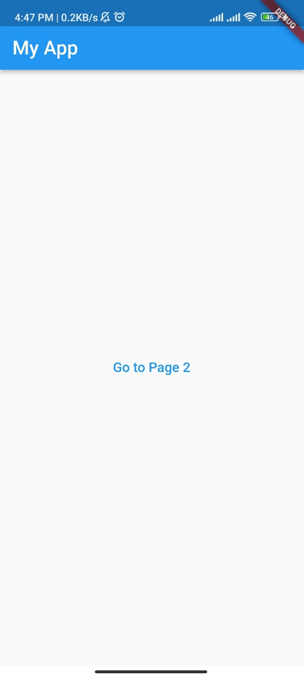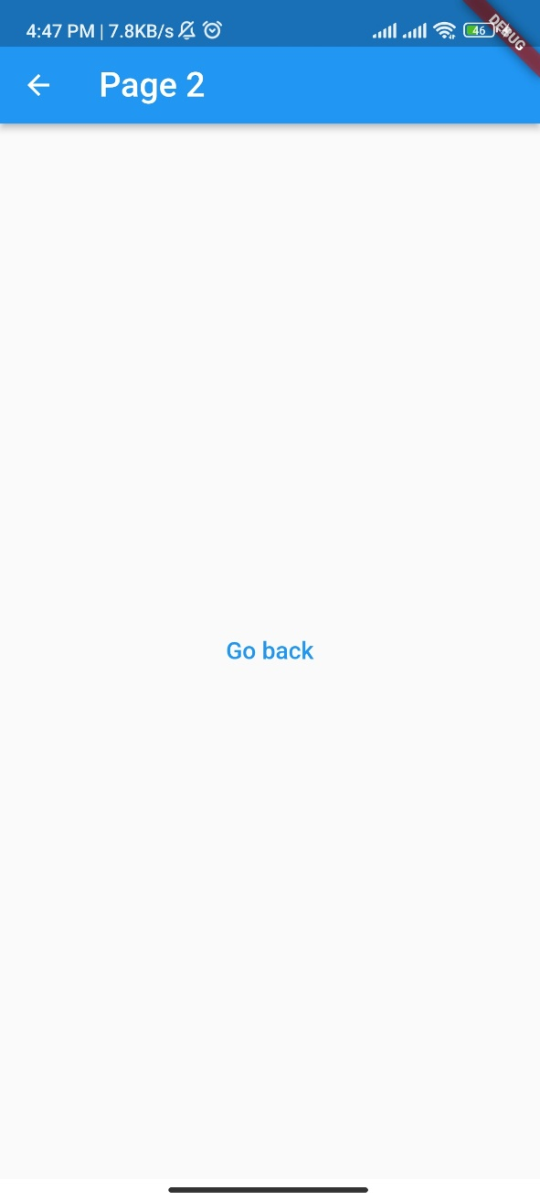

PushReplacement
In Flutter, pushReplacement is a method that allows you to navigate from one screen to another while replacing the current screen in the navigation stack with the new screen. This means that the new screen becomes the topmost screen in the navigation stack, and the previous screen is removed from the stack.
The pushReplacement method is typically used when you want to replace the current screen with a new screen, such as when implementing a login flow. In this scenario, once the user logs in, you would want to replace the login screen with the main screen of the app, so that the user cannot go back to the login screen by pressing the back button.

Navigator.pushReplacement(
context,
MaterialPageRoute(builder: (context) => Page2()),
);

Lecture#12 Navigation
Objectives
- Return data through Navigation
- Alert Dialog
- Stack

Return data through Navigation:
import 'package:flutter/material.dart';

void main() => runApp(MaterialApp(
home: FirstScreen(),
));

class FirstScreen extends StatelessWidget {
@override
Widget build(BuildContext context) {
return Scaffold(
appBar: AppBar(
title: Text('First Screen'),
),
body: Center(
child: TextButton(
child: Text('Go to second screen'),
onPressed: () async {
final result = await Navigator.push(
context,
MaterialPageRoute(builder: (context) => SecondScreen()),
);
print('Selected value: $result');
},
),
),
);
}
}

class SecondScreen extends StatefulWidget {
@override
_SecondScreenState createState() => _SecondScreenState();
}

class _SecondScreenState extends State<SecondScreen> {
String? _selectedValue;

@override
Widget build(BuildContext context) {
return Scaffold(
appBar: AppBar(
title: Text('Second Screen'),
),
body: Center(
child: DropdownButton<String>(
value: _selectedValue,
onChanged: (value) {
setState(() {
_selectedValue = value;
});
},
items: [
DropdownMenuItem(
value: 'Option 1',
child: Text('Option 1'),
),
DropdownMenuItem(
value: 'Option 2',
child: Text('Option 2'),
),
DropdownMenuItem(
value: 'Option 3',
child: Text('Option 3'),
),
],
),
),
floatingActionButton: FloatingActionButton(
child: Icon(Icons.check),
onPressed: () {
Navigator.pop(context, _selectedValue);
},
),
);
}
}

Screenshot:
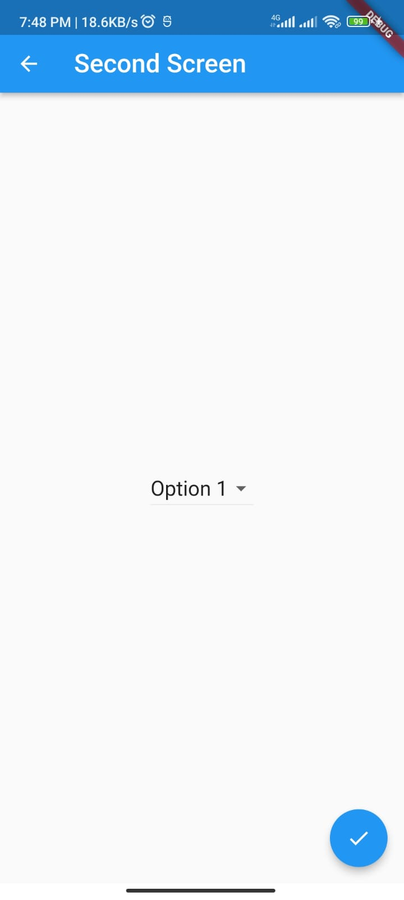

Alert Dialog:
An AlertDialog is a dialog that displays a message and provides the user with buttons to respond. An alert dialog is often used to prompt the user for confirmation before performing a destructive action, such as deleting data.
Here's an example of how to create an AlertDialog in Flutter:
import 'package:flutter/material.dart';
void main() => runApp(MyApp());
class MyApp extends StatelessWidget {
@override
Widget build(BuildContext context) {
return MaterialApp( title: 'Flutter Alert Dialog Example',
home: MyHomePage(),
);
}
}

class MyHomePage extends StatelessWidget {
@override
Widget build(BuildContext context) {
return Scaffold(
appBar: AppBar(
title: Text('Flutter Alert Dialog Example'),
),
body: Center(
child: TextButton (
child: Text('Show Alert Dialog'),
onPressed: () => _showAlertDialog(context),
),
),
);
}

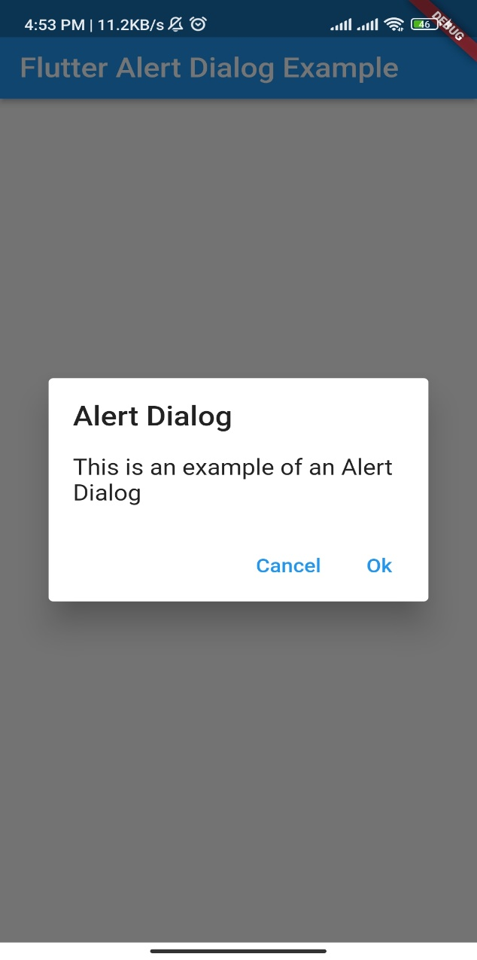
void _showAlertDialog(BuildContext context) {
showDialog(
context: context,
builder: (BuildContext context) {
return AlertDialog(
title: Text('Alert Dialog'),
content: Text('This is an example of an Alert Dialog'),
actions: <Widget>[
TextButton(
child: Text('Cancel'),
onPressed: () {
Navigator.pop(context);
},
),
TextButton(
child: Text('Ok'),
onPressed: () {
Navigator.pop(context);
},
),
],
);
},
);
}
}

AppBar action
The actions property of the AppBar widget in Flutter allows you to add one or more actions or widgets to the right side of the app bar. The actions are usually represented as icons or text and are used to perform quick actions that are related to the content displayed on the screen.
Here's an example of how to add actions to an AppBar in Flutter:
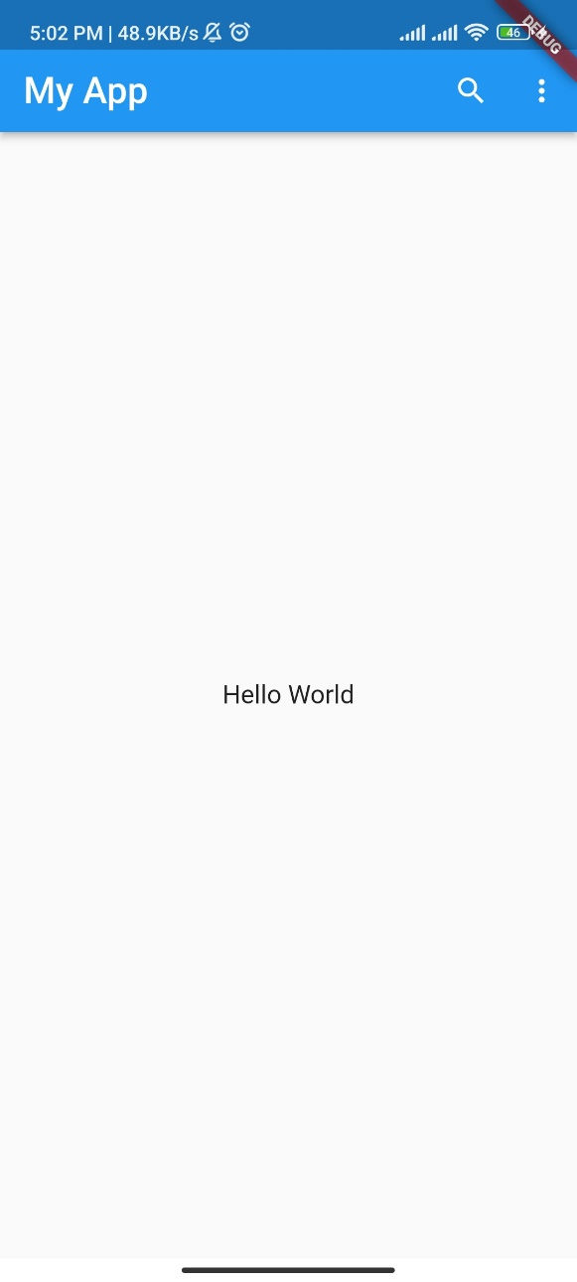
class MyHomePage extends StatelessWidget {
@override
Widget build(BuildContext context) {
return Scaffold(
appBar: AppBar(
title: Text("My App"),
actions: <Widget>[
IconButton(
icon: Icon(Icons.search),
onPressed: () {
// Handle search button press
},
),
IconButton(
icon: Icon(Icons.more_vert),
onPressed: () {
// Handle more button press
},
),
],
),
body: Center(
child: Text("Hello World"),
),
);
}}
Stack:
In Flutter, a Stack widget allows you to position its child widgets on top of each other. The child widgets are drawn in the order in which they are added to the Stack, with the last child being drawn on top of the others. You can control the position of each child widget within the Stack using the Positioned widget.
Here's an example of how to use a Stack widget to position two Container widgets on top of each other:

import 'package:flutter/material.dart';

void main() => runApp(MyApp());

class MyApp extends StatelessWidget {
@override
Widget build(BuildContext context) {
return MaterialApp(
title: 'Stack Example',
home: Scaffold(
appBar: AppBar(
title: Text('Stack Example'),
),
body: Center(
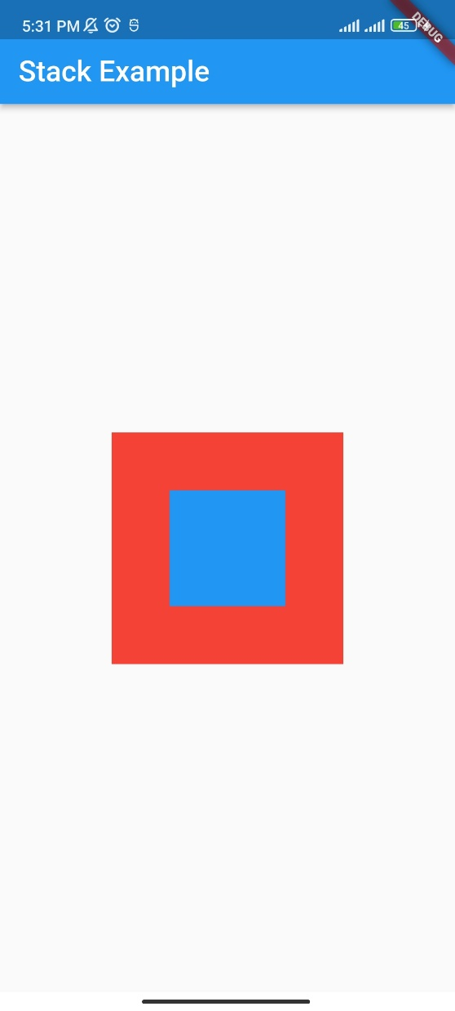
child: Stack(
children: <Widget>[
Container(
width: 200,
height: 200,
color: Colors.red,
),
Positioned(
top: 50,
left: 50,
child: Container(
width: 100,
height: 100,
color: Colors.blue,
),
),
],
),
),
),
);
}
}

